

**Batch: B-2 Roll No.: 16010422234 Experiment No.: 9**

**______________________________________________________________________________**

**Aim:** To create wireframe for Mobile UI – Display of Information

**______________________________________________________________________________**

**Resources needed:** Wireframing tool

**Theory:**

While displaying information on mobile screen user interface designer needs to consider following challenges:

* Small screen size
* Variable screen width
* Touch screens
* Difficulty in typing text
* Challenging physical environments

The UI designer generalized display patterns including Splash screen, onboarding screen, home screen, menu screen, login and profile screen.

**Splash Screen**

A splash screen is the first screen you see when you launch a mobile application. Basically, they were invented to conceal the loading process that software performs before getting fully ready, like with computer games intros.

A perfect splash screen design attracts the user’s interest with impressive illustrations, intriguing headlines, and additional components of an app UI just as the application silently gets ready behind this scene. Other popular functions of splash screens are all about marketing: to say hello and establish the atmosphere for the in-app UX while promoting a brand.

**Onboarding Screen**

The onboarding screens are a collection of screens with a purpose to demonstrate a mobile app’s main features and benefits and lead users through its interface.

**Home Screen**

The home screen is the main component of a mobile application presenting its menu and key features. It’s imperative for designers to make an effort to present users with understandable and functional main screen design.

The composition of home screens is highly dependable on the app’s purpose and may vary a lot because a home screen should present the most frequently used features. However, there are some common features. Since the home screen contains the major mobile app’s options it usually presents an app’s key navigation elements like a search field.

**Log-in and profile Screens**

The majority of modern mobile applications need registration. Profiles make interaction within the mobile application more personalized and allow operating with the data effectively.

**Application Specific Screens**

* Stats Screen
  + Various applications contain stats on user activities. The more data it provides, the harder it is to create a mobile design of a stats screen. Designers need to make sure it is possible to see all the key information still the screen has to be clear and usable. Graph curves, scales, and original icons can make the stats screen look smooth and clean on a mobile app. Moreover, stats screens require distinct typography so that users could easily read the data.
* Catalog Screen
  + Visual presentation plays a particularly important role in e-commerce apps. The best of them showcase the goods in a way to turn people’s heads and boost conversion rates, so the high-res photos are a must. Catalog screens act as shop windows.
* Check out Screen
  + The checkout process is the final step users take before they buy the product. Designers’ task is to make people comfortable while people take this step. First and one of the essential parts of the checkout screen is a form where a buyer fills in specific personal data such as a name and number of the credit card. The type of required information depends on the resource where a user makes a purchase. In addition, it’s important for people to know their personal data is secure, so designers have to reassure users via visual elements that their information is safe.
* Calendar
  + Event apps, to-do list apps, and many others provide users with the personal calendar. Depending on the type of the application, the calendar accomplishes certain functions such as remindings or schedule. The visual style should fit the mood and objectives of the mobile app.

**Managing information in mobile**

* What users want in the context of a mobile app?
  + Design for use contexts such as these:
    - “I need to know this fact right now, quickly.”
    - “I have a few minutes to spare, so entertain me.”
* Approaching essence without layer
  + In fact, make sure that even on the home page (for a website) or the first working page of an app, relevant content appears high on the screen. That means getting rid of the “layer cake effect” of logos, ads, tabs, and headers that stack up on the screen.
* Taking advantage of mobile features
  + Mobile devices offer wonderful features that one doesn't get on the desktop. Location, camera, voice integration, gestural input, haptic feedback such as bumps and vibrations, and other features may be available.
* Linearizing the content
  + This goes back to the width problem. Many devices simply don’t give enough pixels in the width dimension to do any interesting side-by-side layouts.
* Optimize the most common interaction sequences
  + Eliminate typing, or reduce it to as few characters as possible.
  + Use as few page loads as possible
  + Reduce scrolling and sideways dragging, except where it eliminates page loads and typing.
  + Reduce the number of taps it takes a user to reach the desired information or accomplish a task.

**______________________________________________________________________________**

**Procedure:**

Create wireframes incorporating Mobile UI – Page Composition for chosen topic

**Result:**

Splash Screen

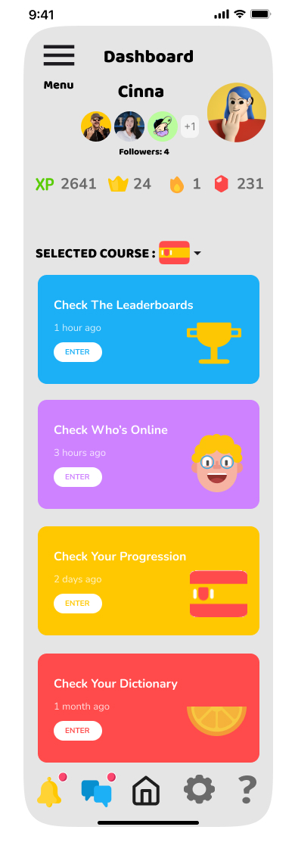

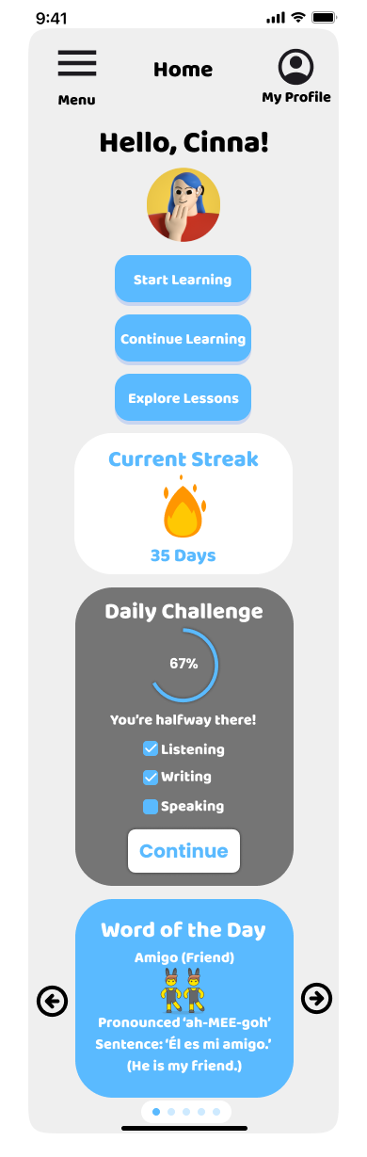Onboarding Screen

Home Screen





Login and Profile Screens

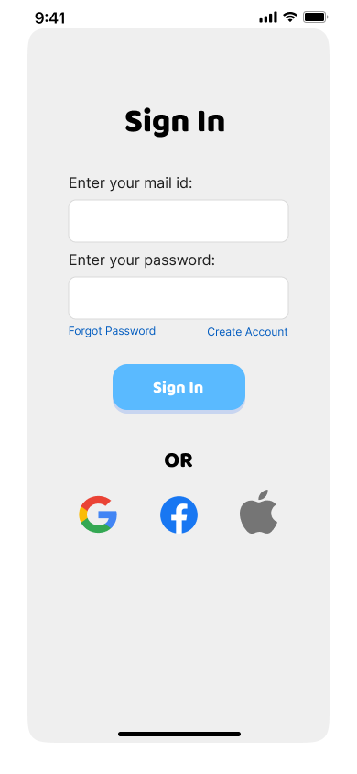

Application Specific Screens (Stats Screen & Catalog Screen)

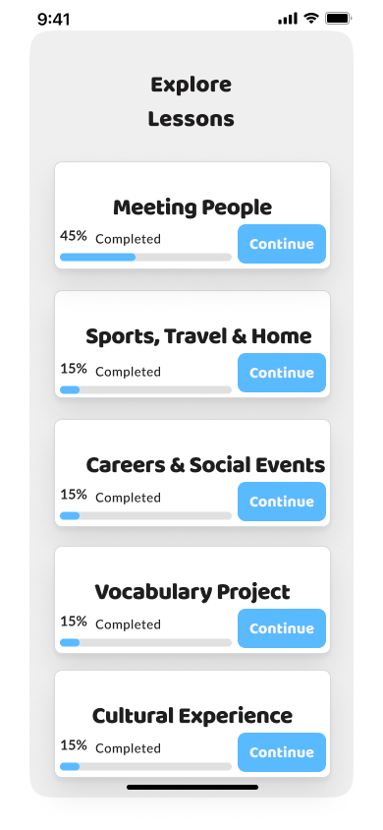

**______________________________________________________________________________**

**Outcomes: Design mobile user interface with UI design patterns**

**______________________________________________________________________________**

**Conclusion: (Conclusion to be based on the objectives and outcomes achieved)**

Through this experiment, we successfully designed a mobile user interface that addresses the challenges unique to mobile displays by utilizing effective UI patterns such as splash screens, onboarding sequences, and interactive home screens. The designs incorporate user-friendly navigation elements, simplified interaction sequences, and visually appealing layouts. This approach ensures an engaging and intuitive experience for language learners, aligning with the app’s goal of making language acquisition accessible and enjoyable. Furthermore, the use of well-defined UI patterns enhances the usability and functionality of the app, thus achieving the design objectives.

**______________________________________________________________________________**

**Grade: AA / AB / BB / BC / CC / CD /DD**

**Signature of faculty in-charge with date**

**______________________________________________________________________________**

**References:**

1. Wilbert O. Galitz, “The Essential Guide to User Interface Design - An Introduction to GUI Design Principles and Techniques”, Wiley Computer Publishing, Second Edition, 2002
2. Steven Hoober, Eric Berkman, “Designing Mobile Interfaces: Patterns for Interaction Design”, O’rielly Media, First Edition, 2012
3. Tidwell, J. (2010). Designing interfaces: Patterns for effective interaction design. " O'Reilly Media, Inc.".

**______________________________________________________________________________**